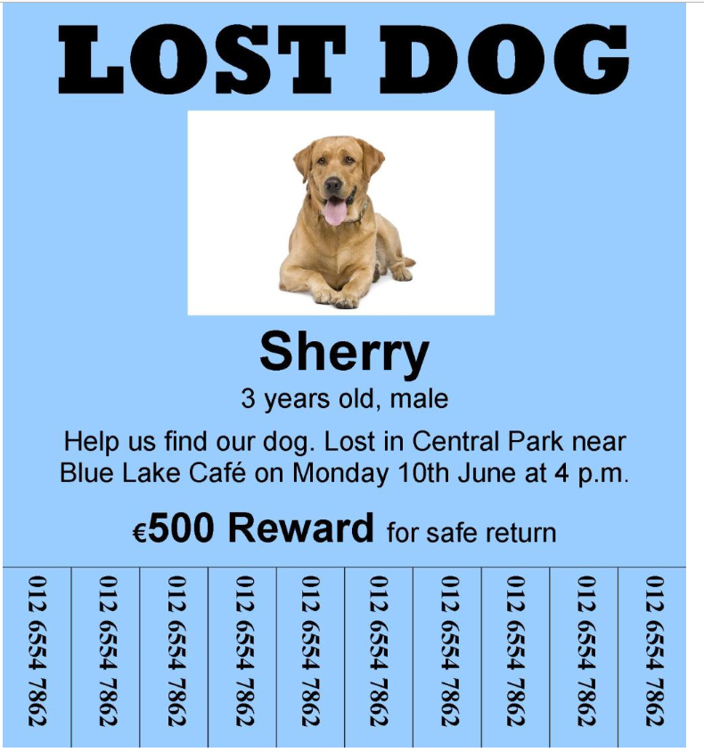

1. Check your understanding: true or false

Bold True or False for these sentences.

1. The dog is lost. True False

2. The dog's name is Sherry. True False

3. The dog is a female. True False

4. The dog was lost on Monday morning. True False

5. The dog was lost in Central Park. True False

6. There is a reward for finding the dog. True False

2. Check your understanding: gap fill

Complete the lost dog report.

LOST DOG REPORT

Dog’s name:

Age:

Date dog was lost:

Time dog was lost:

Place dog was lost:

Money offered for finding dog (Euros):

3 FInish these sentences on the line.

1. The dog is called

2. The dog is five years old